|  |  |
| --- | --- |
|  | |
|  | |
|  |  |

|  |  |
| --- | --- |
| Publication type: |  |
| Publication: | PH |
| Title: |  |
| Subject: |  |
| Issue: | 2.1.1 |
| Publication date: | 2 April 2015 |
| Total number of pages: |  |
| Author: |  |
| Quality Control: |  |

Table of contents

Page #

Figures 3

Tables 4

References 6

Introduction 7

About the Installation Manual 7

Safety instructions 9

Revision history 9

1. Settings in the Devicelist/Sensorlist 10

1.1 Devicelist 10

1.1.1 Protocol 11

1.1.2 Interface 11

1.1.3 Type 11

1.1.4 Options 11

1.1.5 IPAddressUP 11

1.2 Sensorlist 12

2. Valuestate.ini and selection values 12

2.1 Introduction 12

2.2 Valustate.ini 12

2.2.1 Chapters 12

3. Shoremonitoring Mimic 16

3.1 Introduction 16

Figures

Figure 1: Shore monitoring Mimic 16

Figure 2: Field ID 17

Figure 3: Choose an option 17

# Tables

Table 1‑1: Devicelist Columns 10

**NOTICE**

**This document contains proprietary information.**

**No part of this document may be photocopied, reproduced or translated into another language without the prior written consent of   
Imtech B.V.**

References

N/A

Introduction

The shore-monitoring is a functionality of NavVision where you can monitor multiple ships in a single place where you can switch between these ships based on the location of the ship on the dock. This manual is to provide the engineers with the necessary information on how to set everything up within NavVision.

About the Installation Manual

This manual contains the following sections:

* Chapter “Safety instructions” presents warning, caution and note information, which the user should pay attention to.
* Chapter “Setting and adjustment” gives an instruction on how to set and adjust the serial interface.
* Chapter “Technical specifications” contains an overview of the main features and technical data



For specific information on interfaces, but also in depth information on features, mentioned here or not, we refer you to their specific manuals which can be obtained through Imtech.Abbreviations list

SMS Shore Monitoring Protocol

IP Internet Protocol

LAN Local Area Network

N/A Not Applicable

Safety instructions

* This section provides only a summary of the safety requirements and notes in the following sections. To protect your health and prevent damage to the AM(C)S equipment or vessel, it is essential to read and carefully follow the safety instructions.*

The indications NOTE, CAUTION and WARNING have the following significance:



*NOTE:  
An operating procedure, practice or condition etc., which it is important to emphasize.*

**

*CAUTION:*

*An operating procedure, practise or condition etc., which, if not strictly observed, may damage AM(C)S equipment or crash NavVision software.*

* WARNING:*

An operating procedure, practise or condition etc., which, if not carefully observed may result in personal injury or damage to the vessel.

Revision history

Revisions issued since publication.

|  |  |  |  |
| --- | --- | --- | --- |
| **Issue** | **Date** | **Revision** | **Reason** |
| 2.1.1 | April 01, 2015 | New version | Initial new version |

# Settings in the Devicelist/Sensorlist

In the devicelist you need to fill in the divers columns according to the specs given in the Sensorlist Manual. Besides that there are some type-specific settings that we will discuss here.

## Devicelist

The devicelist is the part of the sensorlist where you describe all the devices and interfaces with their respective settings.

The devicelist is separated in different columns which need to be filled with the right data. A few of the columns are optional and merely there for you to put your own comment. These columns are white. The other columns are almost all necessary for the proper working of the system and are colored differently. These colors belong to the different groups which can be divided into interface, port and device. Columns with the same color belong to the same group.

The following columns are in the devicelist:

|  |  |  |
| --- | --- | --- |
| **Column** | **Type** | **Description** |
| Import Result | Text | Checking value by NavVision |
| ID | Text | Any given ID you want or need. |
| Device | Text | Identification of the device where the sensor/control or serial device is connected to. This text should be unique for each NavVision device. The text is case sensitive |
| Comment | Text | Freely to add comment |
| Location | Text | Identification of the substation where the sensor/control is connected to in the NavVision system. (i.e. ER or WH) |
| Protocol | Select | The protocol used for serial connections. |
| Interface | Text  (Index) | Choose the appropriate interface to distinguish the different interfaces in the system |
| Port | Value  (Index) | Port number on the NavVision interface. For MOXA serial servers it’s 1 or 2. On a WAGO it’s always 1. |
| Source | Value  (Index) | Identification of multiple devices on a bus protocol. Used for example for Mod bus (ID byte) and CAN bus (SA byte). Default address is 1. |
| Server | Text | In some cases (like with OPC and WatchIO), you need to specify a server name. |
| Type | Text  (Index) | defines the type of module used to read/control the I/O. |
| Speed | Value  (Index) | The Baudrate the device is communicating with. See devices manual for the appropriate speed. |
| Datalink | Value  (Index) | Defines the parity, databits and stopbit. See devices manual for appropriate settings |
| Hardware | Value  (Index) | Serial communication protocol |
| Options | Text  (comma separated) | Divers special settings for various devices. See devices manual for need of these special demands |
| IPAddressUp | IP-address | IP address of the NavVision interface that’s connected to the device or sensor/control. Up- |
| MACAddressUp | MAC-address | MAC address of the NavVision interface that’s connected to the device or sensor/control. Up-side |
| IPAddressDown | IP-address | IP address of the NavVision interface that’s connected to the device or sensor/control. Down- |
| MACAddressDown | MAC-address | MAC address of the NavVision interface that’s connected to the device or sensor/control. Down-side |
| Connection | Text | Specify the device (see first column) to which this device is connected |
| Connection Port | Value | Specify the port on the device where this device is connected to |
| Visible | Yes/No | Non mandatory field to tell NavVision if the node needs to be visible in the network topology. |

Table ‑: Devicelist Columns

The following columns are important for the ShoreMonitoring:

* Protocol
* Interface
* Type
* Options
* IPAdressUP

### Protocol

For protocol you need to choose “Shore Monitoring”

### Interface

As interface you choose “Network Serial xx” where xx is the number of the networkserial that is freely available.

### Type

As Type you choose the “Serial TCP/IP Client”

### Options

The following options need to be filled (comma separated):

* Registration=KINS (4 letter registration name of the vessel)
* Timeout=120000 (connection timeout in milliseconds)
* Interval=3000 (keepalive interval in milliseconds)
* NoUsePriority (define this to disable sending alarm priority to SMS)

### IPAddressUP

Here you need to fill in an IP-address as well as a port-number (172.16.1.123:9000). The port-number is mandatory. If possible we recommend to use the LocalHost (127.0.0.1).

## Sensorlist

Every line in the sensorlist is a SensorID. If a field in the sensorlist has multiple functions there are more lines for the same field. In this case the field will get more SensorID’s.

If the field is an alarmfield and an alarm appears, the SensorID will be sent to the SMS as an ElementID. With multiple SensorID’s for the same field these will be sent comma-separated.



All alarms from the NavVision system on board, that will normally appear in the Alarm-Mimic, will be sent to the SMS.

# Valuestate.ini and selection values

## Introduction

The Valuestate.ini is an ini-file that can have a setup to trigger multiple choices or enumerations for a specific (value)field. It is not a standard file within NavVision. Once you need it, you will have to create it in the right folder. If there is already a Valuestate.ini you can adjust that with a special chapter for the Shore Monitoring.

## Valustate.ini

If there is not a valuestate.ini yet, you will have to create one. You can do this by creating a new text document in your windows-environment. Rename the text document to “ValueState.uc.ini” (case sensitive). Now you have your new Valuestate.ini. Make sure that you place it in the NavVision>Config>Network-folder.

### Chapters

If it is an existing Valuestate.ini than you can add the following chapter. If it is a new and empty file you just start on the top.

The chapter that you need to create is the following including the brackets and case sensitive:

* [ShoreMonitoringStatus]

This chapter is filled with a Field ID of NavVision. In this case we are going to describe the status of the ShoreMonitoring. By putting this in teh ValueState.ini we can divide it in to different state’s where we can choose from, or show on a mimic within NavVision.

So for example we want to have the following state’s for the status:

* State_0=0,Uit
* State_1=1,Starten
* State_2=2,Actief
* State_3=3,Stoppen



The numbering is 0-based. Make sure that you at least start with 0 and follow it up. The order you put it in is less important.

If you now select a valufield in the mimic in NavVision you can choose one of these options. And that option will be shown in the Value-window.

The same we can do for the following fields of the shore monitoring:

* ShoreMonitoringShipDirection
* ShoreMonitoringDock
* ShoreMonitoringSubDock
* ShoreMonitoringTier

Now for instance when you select a certain dock where a vessel lies, you can create dependable entries for that dock. For example when dock 1 has an east and a west part, you can define that in the ValueState.ini to make sure that choice comes available. If this goes for more docks, you can mention all these docks in the chapter where you define the east west selection.

These selections all must have a distinct name. So if you create a special subdock it wil be written down as:

* [Selection1_ShoreMonitoringSubDock]

The first part is free, you can give it a descriptive name as you like. Beneath that chapter you can fill in the necessary distinction that you need to describe. So in this example:

* [Selection1_ShoreMonitoringSubDock]
* SelectionValues=12,13,14,16,17
* SelectionField=ShoreMonitoringDock
* State_0=1,Oost
* State_1=0,West
* FieldCount=1

Now you say that for dock (SelectionField=ShoreMonitoringDock) 12,13,14,16,17 you will have a subdock selection “Oost” or “West”. So in the mimic in NavVision you can now select either of these docks and in the subdock selection pane you can choose if it is on the east side or the west side.



The name of the state is freely adjustable. So instead of Oost you can make it East or even Oostzijde van de steiger.

The second selection will be different so you name it different (first part of the chapter name). Let’s say the next selection is the following:

* [Selection2_ShoreMonitoringSubDock]
* SelectionValues=63
* SelectionField=ShoreMonitoringDock
* State_0=0,Oost
* State_1=1,Midden
* State_2=2,West
* FieldCount=1

So for dock number 63 you will have different choices for the subdocks.

This way you fill up the ValueState.ini with all the choices that are needed. In this case a typical ValueState.ini can look, for the ShoreMonitoring part, as follows:

* [ShoreMonitoringStatus]
* State_0=0,Uit
* State_1=1,Starten
* State_2=2,Actief
* State_3=3,Stoppen
* FieldCount=1
* [ShoreMonitoringShipDirection]
* State_0=0,Land
* State_1=1,Zee
* FieldCount=1
* [ShoreMonitoringDock]
* State_0=8,Steiger 08
* State_1=9,Steiger 09
* State_2=10,Steiger 10
* State_3=11,Steiger 11
* State_4=12,Steiger 12
* State_5=13,Steiger 13
* State_6=14,Steiger 14
* State_7=15,Steiger 15
* State_8=16,Steiger 16
* State_9=17,Steiger 17
* State_10=18,Steiger 18
* State_11=19,Steiger 19
* State_12=20,Steiger 20
* State_13=21,Steiger 21
* State_14=22,Steiger 22
* State_15=23,Steiger 23
* State_16=24,Steiger 24
* State_17=60,Steiger 60
* State_18=61,Steiger 61
* State_19=62,Steiger 62
* State_20=63,Steiger 63
* State_21=101,DOK6
* State_22=102,SLC hal
* State_23=103,SLC
* State_24=104,SLC T
* FieldCount=1
* [Selection0_ShoreMonitoringSubDock]
* SelectionValues=8,9,10,11,18,24,61,62,102,104
* SelectionField=ShoreMonitoringDock
* State_0=0,-
* FieldCount=1
* [Selection1_ShoreMonitoringSubDock]
* SelectionValues=12,13,14,16,17
* SelectionField=ShoreMonitoringDock
* State_0=1,Oost
* State_1=0,West
* FieldCount=1
* [Selection2_ShoreMonitoringSubDock]
* SelectionValues=60,101
* SelectionField=ShoreMonitoringDock
* State_0=0,Oost
* State_1=1,West
* FieldCount=1
* [Selection3_ShoreMonitoringSubDock]
* SelectionValues=15
* SelectionField=ShoreMonitoringDock
* State_0=2,Oost
* State_1=1,Midden
* State_2=0,West
* FieldCount=1
* [Selection4_ShoreMonitoringSubDock]
* SelectionValues=63
* SelectionField=ShoreMonitoringDock
* State_0=0,Oost
* State_1=1,Midden
* State_2=2,West
* FieldCount=1
* [Selection5_ShoreMonitoringSubDock]
* SelectionValues=20,21,22,23
* SelectionField=ShoreMonitoringDock
* State_0=1,Noord
* State_1=0,Zuid
* FieldCount=1
* [Selection6_ShoreMonitoringSubDock]
* SelectionValues=19
* SelectionField=ShoreMonitoringDock
* State_0=2,Noord
* State_1=1,Midden
* State_2=0,Zuid
* FieldCount=1
* [Selection7_ShoreMonitoringSubDock]
* SelectionValues=103
* SelectionField=ShoreMonitoringDock
* State_0=3,A1
* State_1=2,A2
* State_2=1,B
* State_3=0,C
* FieldCount=1
* [ShoreMonitoringTier]
* State_0=0,Binnenzijde
* State_1=1,Buitenzijde
* FieldCount=1

Fieldcound=1 you can leave as is.

# Shore monitoring Mimic

## Introduction

The mimic within NavVision is freely adjustable. To understand how to work with mimics, we recommend that you read the mimic manual. The shore monitoring manual is a fairly easy mimic with a button and a few values. It can look as the following mimic that was made for this example.

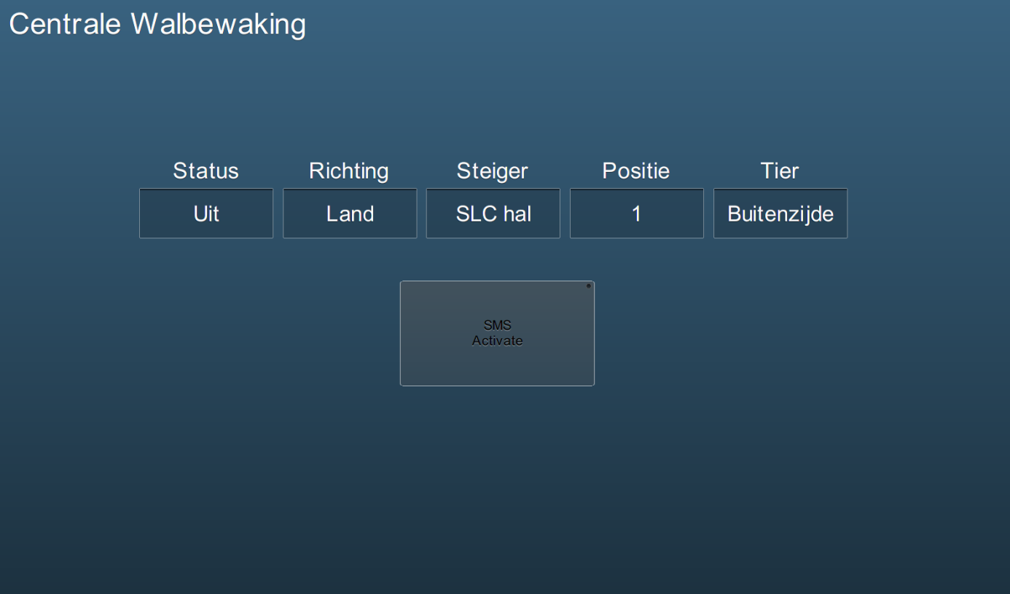

Figure : Shore monitoring Mimic

For the values you use the fields that we defined in the ValueState.ini. You can find them under System (see Figure 2).

Once you have defined these values in the mimic and the ValueState.ini is correct, you can start and stop the monitoring with the button “SMS Activate” Shore Monitoring System activate.When a ship is connected it will send a status to the system ashore. Then you can select the right dock (see ) and the rest of the positions to see the status of the connection of the vessel/dock.

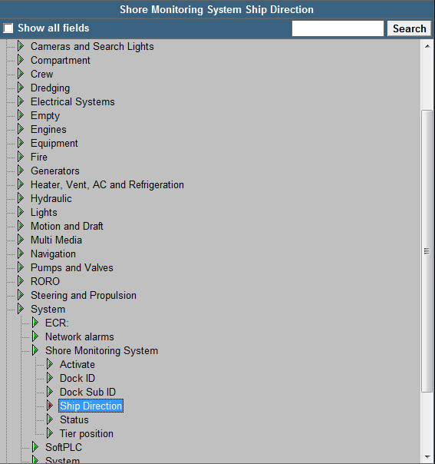

Figure : Field ID

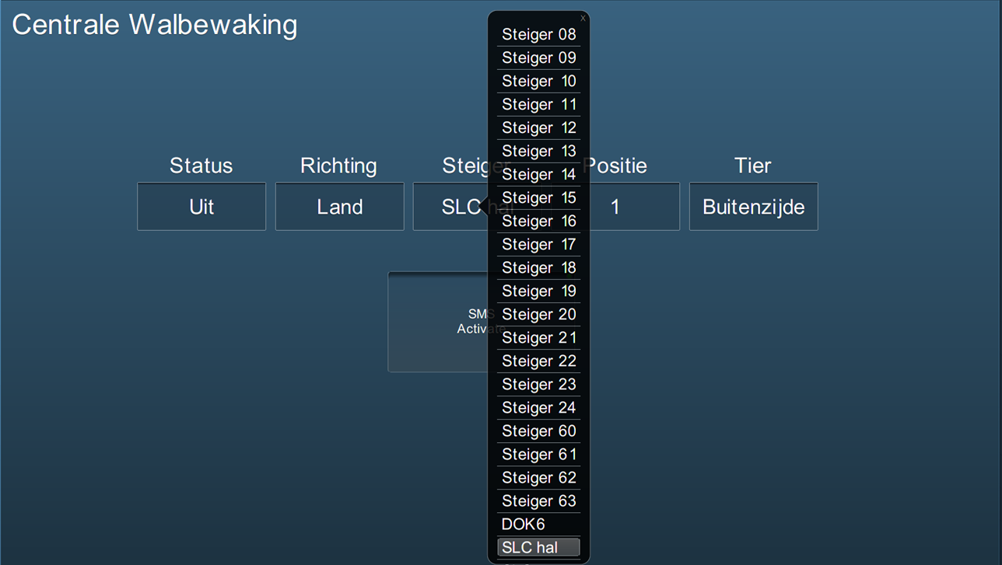

Figure : Choose an option